# PROJECT DEVELOPMENT PHASE

**Delivery of Sprint - 01**

|  |  |
| --- | --- |
| DATE | 17.11.2022 |
| TEAM ID | PNT2022TMID34387 |
| PROJECT TITLE | RETAIL STORE STOCK INVENTORY ANALYSIS |

# SPRINT 1

* DATA COLLECTION
* DATA PREPARATION

Data Collection:

1. Download dataset:

Dataset link : <https://drive.google.com/file/d/1TGCey9xTxKsg1g1g8H_Ym1QGblA_r0KK/view>

1. Uploading dataset:

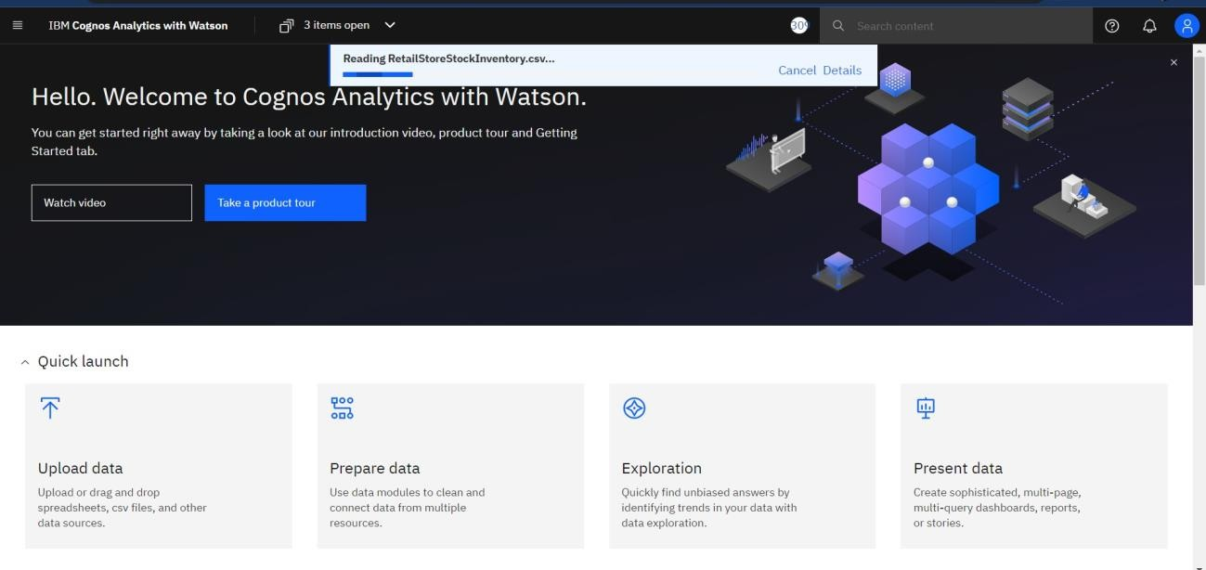

Choosing the dataset for preparation

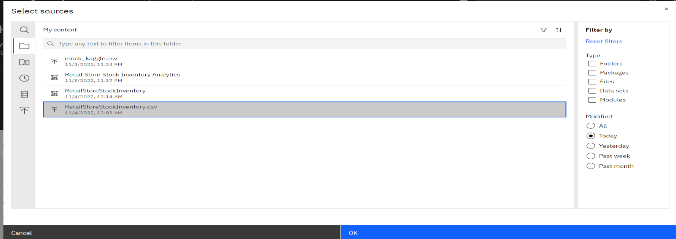

Month data: Calculation Creation

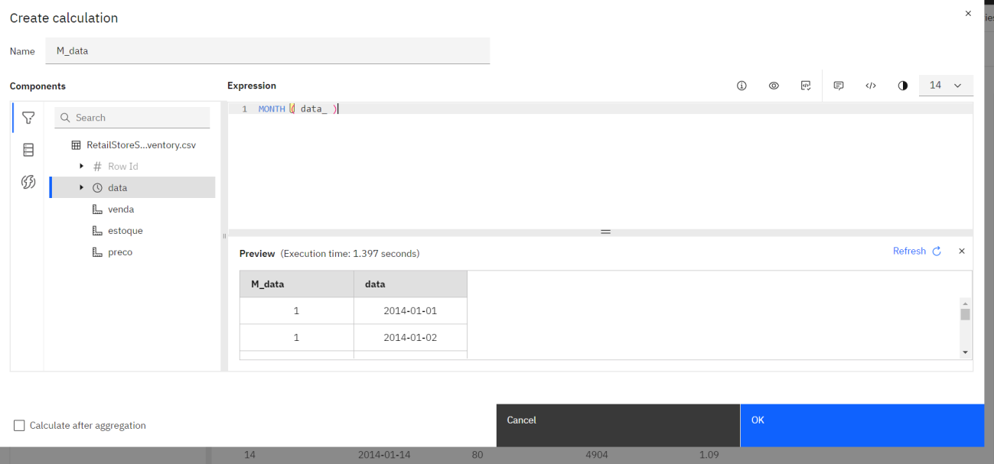

Formatting Month Data:

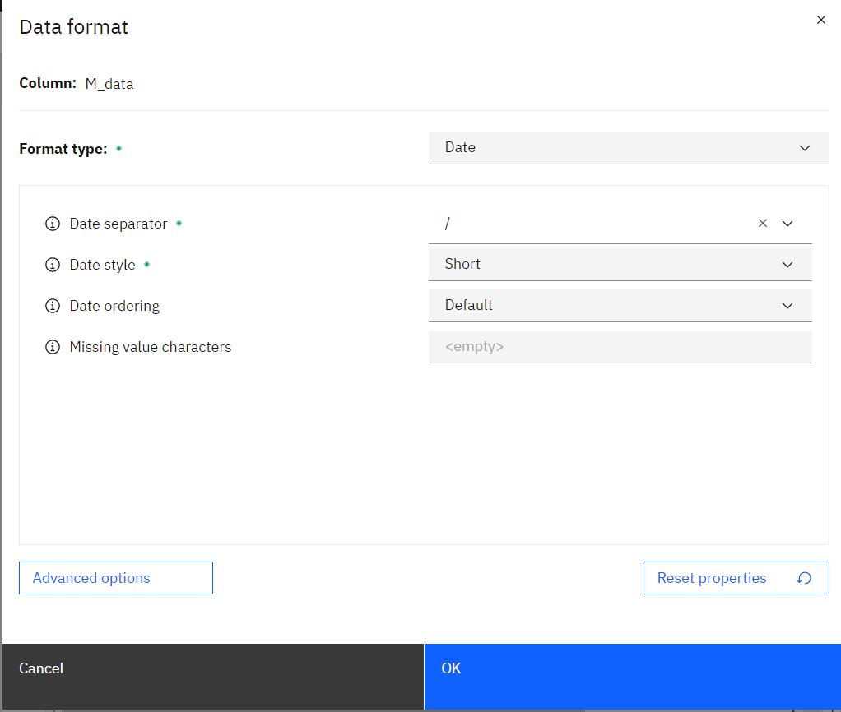

Formatting year data:

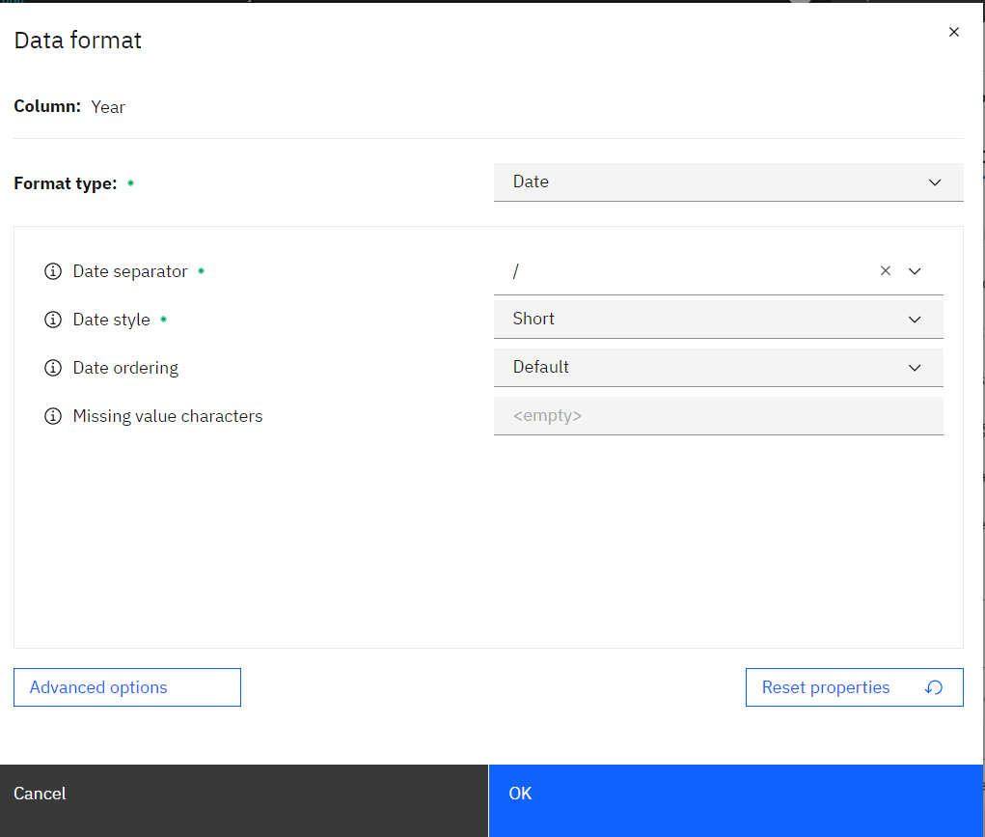

Formatting sale data

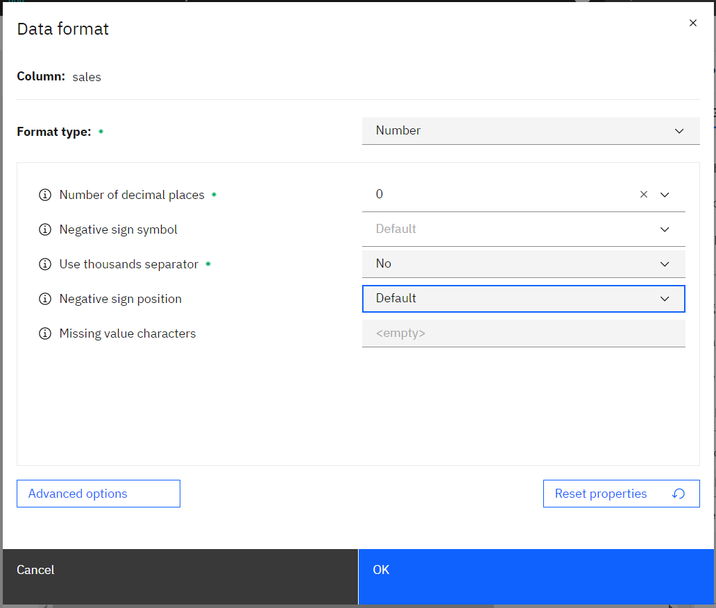

Formatting stock data:

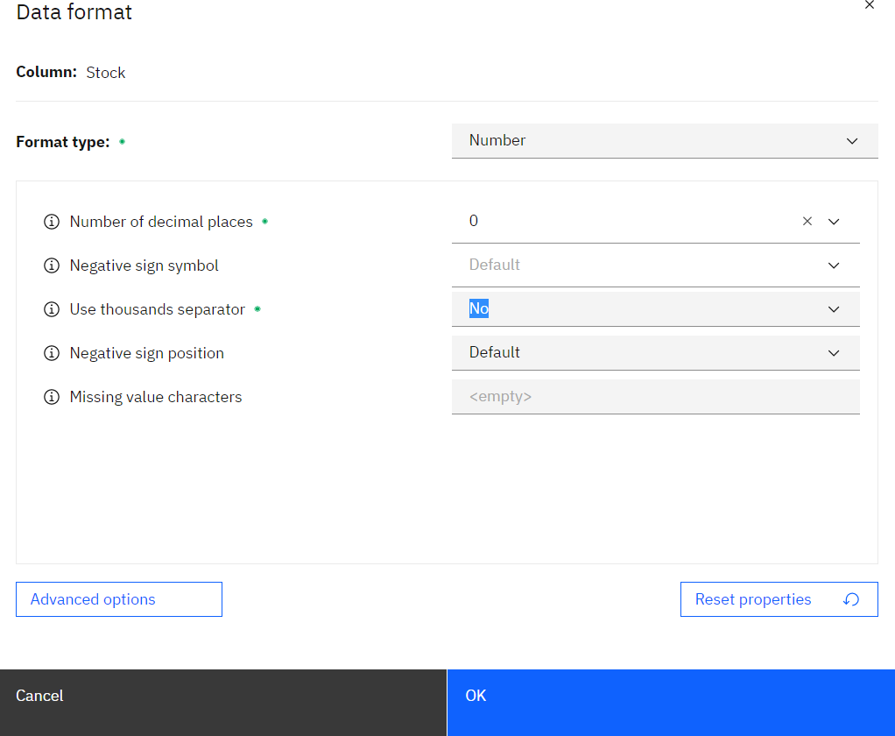

Formatting price data:

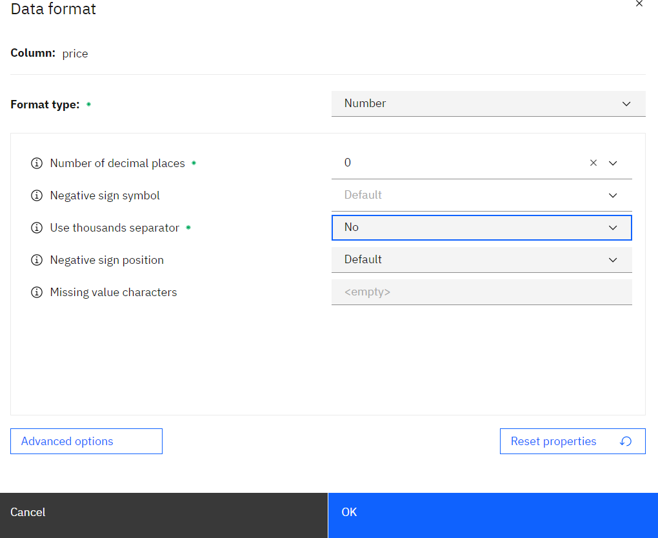

View data:

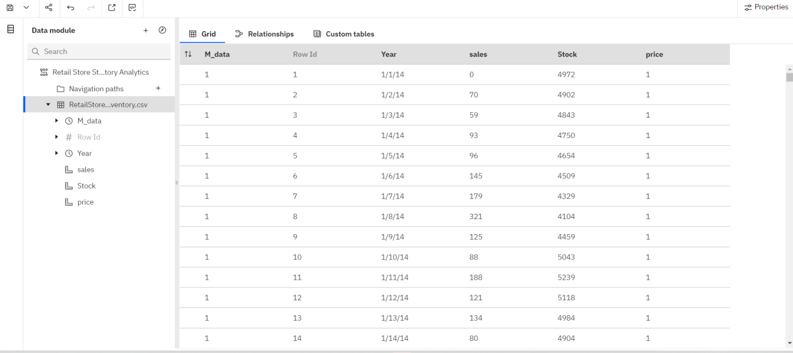

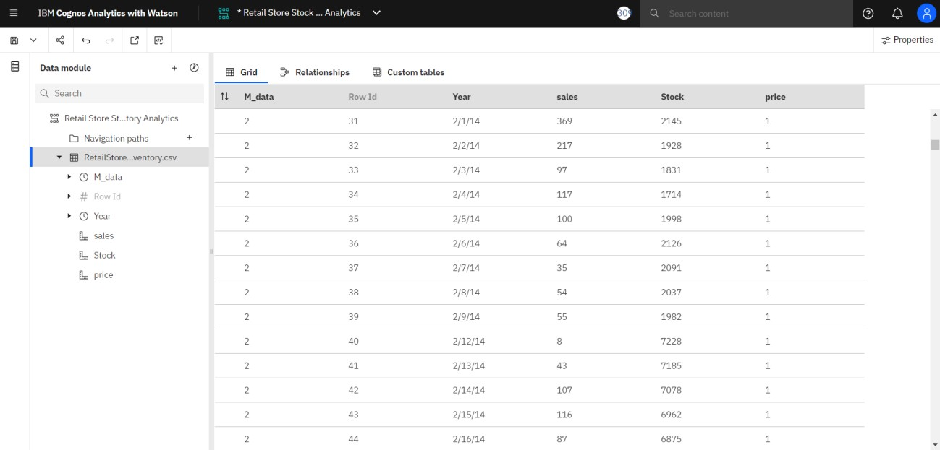

Inventory module link:

[https://us1.ca.analytics.ibm.com/bi/?perspective=ca-](https://us1.ca.analytics.ibm.com/bi/?perspective=ca-modeller&pathRef=.my_folders%2FRetail%2BStore%2BStock%2BInventory%2BAnalytics) [modeller&pathRef=.my_folders%2FRetail%2BStore%2BStock%2BInventory%](https://us1.ca.analytics.ibm.com/bi/?perspective=ca-modeller&pathRef=.my_folders%2FRetail%2BStore%2BStock%2BInventory%2BAnalytics) [2BAnalytics](https://us1.ca.analytics.ibm.com/bi/?perspective=ca-modeller&pathRef=.my_folders%2FRetail%2BStore%2BStock%2BInventory%2BAnalytics)